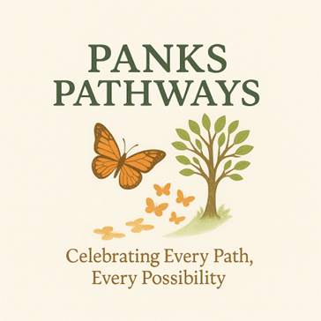

WORK AGREEMENT
This agreement is made between:
Panks Pathways, operated by Mrs Claire Panks (Sole Trader)
and
Parent/Carer Name: _____________________________________
Client Name: ___________________________________________
Address: ______________________________________________
_____________________________________________________
Date of Agreement: ____ / ____ / _______

1. Nature of Work
Mrs Claire Panks of Panks Pathways agrees to provide learning mentor and/or personal care services for the above-named client, as agreed with the parent/carer.

2. Hours of Work and Payment
• Agreed hourly rate: £30 per hour (for 1-1 bespoke tutoring) (Personal Assistance/Respite /Mentoring packages vary subject to individual needs assessment)
• Agreed hours/reoccurring day of work: ________________________________________
• Payment method and schedule to be agreed prior to sessions. (see note 9)

3. Transport and Mileage
• The parent/carer confirms they are happy for Mrs Claire Panks to use her personal car, where necessary, to transport the client to and from community activities.
• Mileage will be charged at 45p per mile in addition to the hourly rate, for clients based beyond 4 miles of the registered address CM3 3DJ. In addition to any other transport required for activities.

4. First Aid and Medication
The parent/carer confirms they are happy for Mrs Claire Panks to administer first aid and any pre-agreed medication if necessary. Any such medication will only be given following prior written agreement between both parties.

5. Cancellations
• Cancellations must be made at least 48 hours before the agreed start time.
• If cancellation occurs within 48 hours, full payment for the session will still be required.
• If cancellation is made before 48 hours, any payment already made will be transferred to the next session.

6. Work Environment
The parent/carer agrees that:
• Mrs Claire Panks may work in their home with the client.
• Sessions may also take place online, where appropriate and agreed.

7. Medical and Personal Information
A medical form has been completed and signed by both Mrs Claire Panks (Panks Pathways) and the parent/carer of the client. All personal and medical information is handled in accordance with GDPR regulations and treated with the utmost confidentiality.
8. Physical Support & Safeguarding Consent Disclaimer
When required only: - A signed consent is in place (as detailed in a separate Physical Support and Safeguarding Consent Disclaimer document) for appropriate physical support to be used where necessary to safeguard and support the child.
Parent/Carer Declaration:
I confirm that I understand and agree to the terms outlined in this agreement and that I am happy for the work to be undertaken as stated above.
Parent/Carer Signature: ___________________________
Print Name: _____________________________________
Date: ____ / ____ / _______
Mrs Claire Panks – Panks Pathways
I confirm that I have explained the terms of this agreement and will provide services as outlined above.
Signature: ___________________________
Date: ____ / ____ / _______
9) Payment to be made
All tutoring fees must be paid in advance. Payment is required prior to the commencement of lessons and will cover sessions scheduled up to the upcoming half-term break.
Fees for the full period up to half term must be received before the first lesson of that period. Lessons will only be confirmed once payment has been received.

