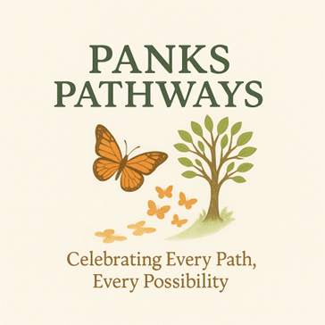

WORK AGREEMENT
This agreement is made between:
Panks Pathways, operated by Mrs Claire Panks (Sole Trader)
and
Parent/Carer Name: _____________________________________
Client Name: ___________________________________________
Address: ______________________________________________
_____________________________________________________
Date of Agreement: ____ / ____ / _______

1. Nature of Work
Mrs Claire Panks of Panks Pathways agrees to provide learning mentor and/or personal care services for the above-named client, as agreed with the parent/carer.

2. Hours of Work and Payment
• Agreed hourly rate: £25 per hour (Introductory 3 month rate)
• Agreed hours/dates of work: ________________________________________
• Payment method and schedule to be agreed prior to sessions.

3. Transport and Mileage
• The parent/carer confirms they are happy for Mrs Claire Panks to use her personal car, where necessary, to transport the client to and from community activities.
• Mileage will be charged at 45p per mile in addition to the hourly rate, for clients based beyond 6 miles of the registered address CM3 3DJ. In addition to any other transport required for activities.

4. First Aid and Medication
The parent/carer confirms they are happy for Mrs Claire Panks to administer first aid and any pre-agreed medication if necessary. Any such medication will only be given following prior written agreement between both parties.

5. Cancellations
• Cancellations must be made at least 48 hours before the agreed start time.
• If cancellation occurs within 48 hours, full payment for the session will still be required.
• If cancellation is made before 48 hours, any payment already made will be transferred to the next session.

6. Work Environment
The parent/carer agrees that:
• Mrs Claire Panks may work in their home with the client.
• Sessions may also take place online, where appropriate and agreed.

7. Medical and Personal Information
A medical form has been completed and signed by both Mrs Claire Panks (Panks Pathways) and the parent/carer of the client. All personal and medical information is handled in accordance with GDPR regulations and treated with the utmost confidentiality.

8. Signatures
Parent/Carer Declaration:
I confirm that I understand and agree to the terms outlined in this agreement and that I am happy for the work to be undertaken as stated above.
Parent/Carer Signature: ___________________________
Print Name: _____________________________________
Date: ____ / ____ / _______
Mrs Claire Panks – Panks Pathways
I confirm that I have explained the terms of this agreement and will provide services as outlined above.
Signature: ___________________________
Date: ____ / ____ / _______

